**chat DBdiagram.io**

**Code:**

**Enum "request_type_enum" {**

**"daily_operations"**

**"move_in"**

**"intercom_change"**

**"access"**

**"common_area_report"**

**"question"**

**}**

**Enum "request_status_enum" {**

**"Received"**

**"In progress"**

**"Completed"**

**}**

**Enum "account_account_type_enum" {**

**"Public"**

**"Owner"**

**"Renter"**

**"Employee"**

**"Admin"**

**}**

**Table "file" {**

**"file_id" VARCHAR(255) [pk]**

**"title" TEXT [not null]**

**"content" TEXT [not null]**

**"property_id" VARCHAR(255) [not null]**

**}**

**Table "post" {**

**"post_id" VARCHAR(255) [pk]**

**"property_id" VARCHAR(255) [not null]**

**"creator_id" INT [not null]**

**"content" TEXT [not null]**

**"replied_to" VARCHAR(255)**

**"posted_at" TIMESTAMP**

**}**

**Table "account" {**

**"account_id" VARCHAR(255) [pk]**

**"fullname" TEXT [not null]**

**"password" TEXT [not null]**

**"email" TEXT [not null]**

**"phone_number" TEXT**

**"profile_picture" TEXT**

**"registration_key" VARCHAR(255)**

**"account_type" account_account_type_enum [not null]**

**"created_at" TIMESTAMP**

**}**

**Enum "employee_type_enum" {**

**"manager"**

**"accountant"**

**"daily_operator"**

**}//**

**Enum "occupant_type_enum" {**

**"owner"**

**"renter"**

**}//**

**Table "request" {**

**"request_id" VARCHAR(255) [pk]**

**"unit_id" TEXT [ref: > unit.unit_id]**

**"employee_id" TEXT**

**"type" request_type_enum**

**"description" TEXT**

**"status" request_status_enum**

**}//**

**Table "property" {**

**"property_id" VARCHAR(255) [pk]**

**"admin_id" VARCHAR(255) [not null, ref: > "CMC_Admin"."admin_id"]**

**"unit_count" INT**

**"locker_count" INT**

**"parking_count" INT**

**"address" TEXT**

**"picture" TEXT**

**}//**

**Table "unit" {**

**"unit_id" VARCHAR(255) [pk]**

**"property_id" VARCHAR(255) [not null]**

**"occupant_id" VARCHAR(255) [ref: > "account"."account_id"]**

**"occupant_registration_key" VARCHAR(255)**

**"occupant_type" occupant_type_enum**

**"size" INT**

**"monthly_rent" DECIMAL(10,2)**

**"condo_fee" DECIMAL(10,2)**

**"condo_balance" DECIMAL(10,2)**

**"parking_spot" bool**

**}//**

**Table "property_operations"{**

**"property_id" VARCHAR(255)**

**"operation_id" VARCHAR(255)**

**"operation_name" VARCHAR(255)**

**"operation_cost" decimal**

**}**

**Table "employee" {**

**"employee_id" VARCHAR(255) [pk]**

**"property_id" VARCHAR(255) [ref: > "property".property_id]**

**"type" employee_type_enum [not null]**

**}//**

**Table "CMC_Admin" {**

**"admin_id" VARCHAR(255) [pk, ref: - "account".account_id]**

**"company_name" VARCHAR(255)**

**"parking_spot_fee" double**

**"fee_per_square_foot" double**

**}//**

**Ref:"employee"."employee_id" < "request"."employee_id"**

**Ref:"property"."property_id" < "file"."property_id"**

**Ref:"property"."property_id" < "unit"."property_id"**

**Ref:"property"."property_id" < "post"."property_id"**

**Ref:"account"."account_id" < "post"."creator_id"**

**Ref:"post"."post_id" < "post"."replied_to"**

**Ref:"account"."account_id" - "employee"."employee_id"**

**Ref: "property"."property_id" < property_operations.property_id**

**CURRENT:**

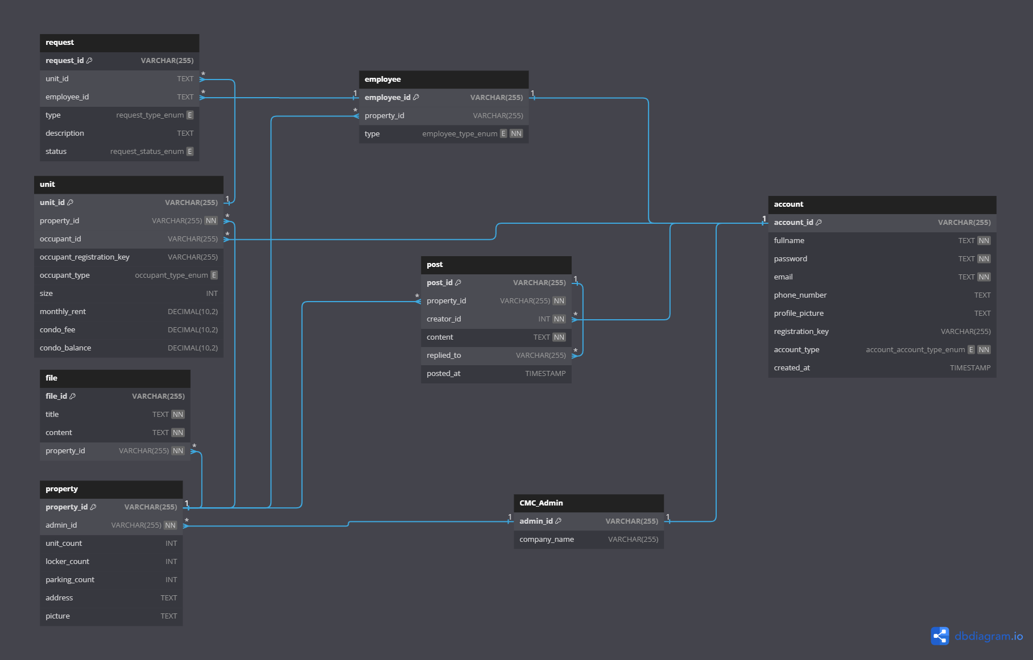

**PREVIOUS:** 